|  |  |
| --- | --- |
|  | UPHS Floorplan Graphics & Navigation Specifications |
| Schneider Electric Vector Logo | Free Download - (.SVG + .PNG ... |
| Schneider Electric Building Operations Software Team |
| **TGML Floorplan Graphics**  Building Operations Graphics Editor v3.0  www.schneider-electric.com/buildings |
| **,**  Phone: 215-443-0442 |
| **2022** |
|  |
|  |

Table of Contents

1. Introduction
   1. 1.1 Purpose
2. Floorplan Specifications
   1. 2.1 Area Level Features
   2. 2.2 Floor Level Features
   3. 2.3 Mechanical Floors
3. Navigation Specifications
   1. 3.1 Navigation Header
   2. 3.2 Navigation Header Features
4. Review and Acceptance

# 1 INTRODUCTION

## 1.1 Purpose

* The purpose of the Floorplan Graphics Specifications is to give an overview of the floorplan graphic functionality and system navigation used by Schneider Electric for building management systems in UPHS: The Pavilion Project.

# 2 FLOORPLAN SPECIFICATIONS

## 2.1 Area Level Features

* TGML Specifications
  + The base dimensions of the TGML will be 1024 X 1670. If the floorplan graphic requires more space then the dimensions can be increased incrementally by 10%.
  + For example, if 10% more space is needed, the dimensions will be 1126 X 1837. If 20% more space is needed, then the dimensions will be 1229 X 2004 and so on.
  + Global scripts must be set to true
* Zone Components
  + Zone components will cover most of the floor. They are polygons which fit the outline of an area being served by a single piece of equipment. Below is a zone component that covers a single patient room in the Penn Pavilion. 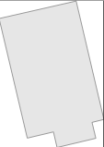
  + 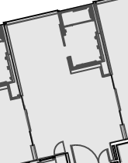This zone component is then superimposed on a floorplan containing the patient room, shown below.
* Summary Lines
  + Summary Lines are located directly to the right or under the floorplan. If more space is needed, expand the TGML dimensions, making sure to maintain the original dimension ratio.
  + Summary Lines will have as many rows as the number of equipment monitored.
  + Each summary line will have seven columns in this order, from left to right.
    - Zone
    - Heating Setpoint
    - Cooling Setpoint
    - Room Temperature
    - Relative Humidity
    - Room Differential Pressure
    - CO2
  + The name of each summary line is an abbreviated equipment ID. “HUP-XX” is implied, so we will write “VCV-SA-XXXX” as the line name.
  + As the points are bound the summary line columns will populate.
  + An example of a summary line in a graphic is shown below. Values have been simulated for VCV-SA-1102
* 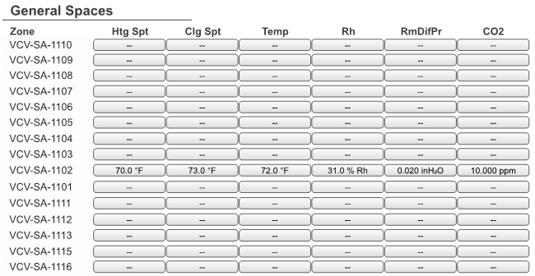Summary Line-Zone Component Relationship
  + Each summary line and zone component are tied together by their hlGroup attribute. A zone component in hlGroup “HUP-10-VCV-SA-1102” is tied to a summary line in hlGroup “HUP-10-VCV-SA-1102”
  + 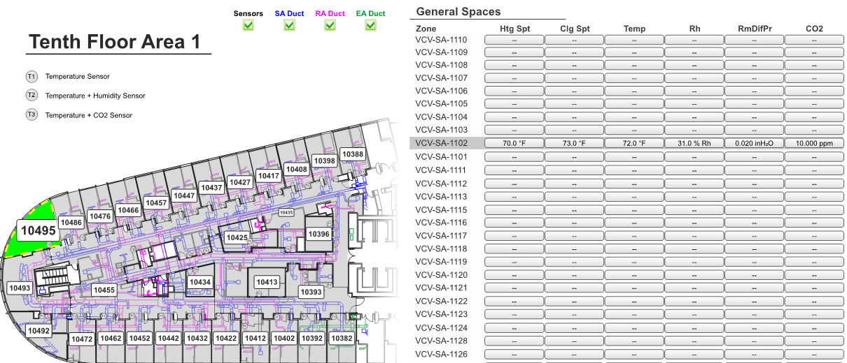Their animations are triggered by “MouseOver” events. For example, when hovering over a summary line, the line will highlight with a gray background. The corresponding zone component will also react. Its room label will enlarge and a dashed yellow outline will appear. See example below.
* Hovering over the zone component will also cause the summary line to react if they are in the same hlGroup.
* Links
  + Links are a property of every summary line and zone component. Clicking anywhere on a summary line or zone component will take you to that specific equipment graphic.
* Toggled Layers
  + Each area level graphic has four toggled layers. There are checkboxes at the top which control visible layers. The layers that can be toggled are as follows.
    - Sensors
    - Supply Duct
    - Return Duct
    - Exhaust Duct



* Alarms
  + 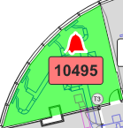The 6 points shown on the summary lines each have alarms bound to them. If any point is in alarm, it’s fill will turn red. All points are included in the general alarm. For the zone component, the general alarm bell will be visible and the room label will flash red if any are in alarm.
* Alarm Trigger Conditions
  + Heating Setpoint – Room temperature falls below heating setpoint’s span for more than 60 minutes.
  + Cooling Setpoint – Room temperature rises above cooling setpoint’s span for more than 60 minutes.
  + Room Temperature – Room temperature sensor fails.
  + Room Humidity – When occupied, relative humidity is out of ideal range. Currently ideal range is between 30% and 60%.
  + RmDifPr – Room differential pressure is out of ideal range for 1 minute. Ideal range is between 0.01 and 0.03 inH2O.
  + CO2 - CO2 level is greater than setpoint + 100 ppm for 5 minutes.
* Temperature Gradient
  + The temperature gradient bar shows what colors correspond to different room temperature conditions.
  + Temperature color change conditions
    - If room temperature is within heating and cooling setpoint, zone fill is lime green.
    - If room temperature falls 1° below heating setpoint, zone fill turns lighter lime green.
    - As room temperature reaches heating setpoint span, the zone fill becomes darker blue. Once span difference is met, zone fill is at the darkest blue. Any temperature below span will not change fill color.
    - If room temperature rises 1° above cooling setpoint zone fill turns mustard yellow.
    - As room temperature reaches cooling setpoint span, the zone fill becomes darker red. Once span difference is met, the zone fill is at the darkest red. Any temperature above span will not change fill color.
  + If the room temperature is outside of the span for more than 60 minutes either a cooling or heating setpoint alarm will trigger and the zone component will remain that color while showing the bell and flashing room label.



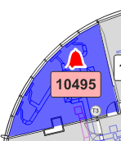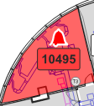

Cooling Setpoint Alarm

Heating Setpoint Alarm

* Loss of communications
  + 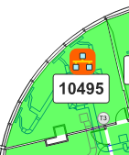Whenever a controller loses connection with the server, the summary line will get a dark orange fill and bound points will show a network image. The zone component will also show a network image.



* Return VAV Indications
  + Return VAVs are indicated by black diamonds, which are placed at the return VAV’s physical location on the floor. See the next page for an example

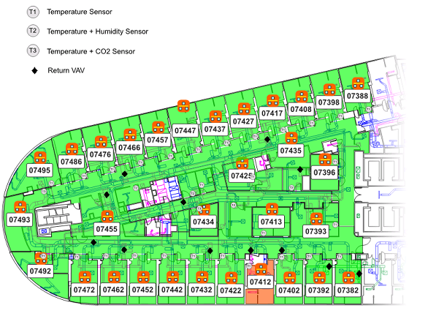

* + We see the black diamonds placed on top of where the return VAV boxes physically reisde in the area.
  + Hovering over a return VAV will display three types of components on the graphic
    - A separate table containing the following points from the controller
      * Return Flow
      * Return Flow Setpoint
      * Return Flow Alarm
    - All zones served by the return VAV are outlined in a dashed yellow line
    - The summary lines associated with those zones are also highlighted
  + 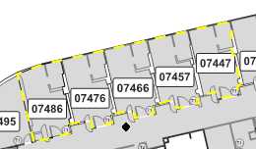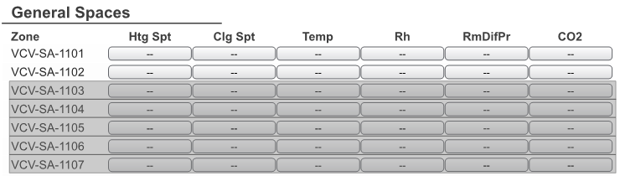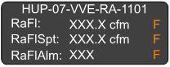Below are the three components that are displayed when hovering over the black diamond associated with HUP-07-VVE-RA-1101. The next page shows where these components show up on the overall floorplan graphic

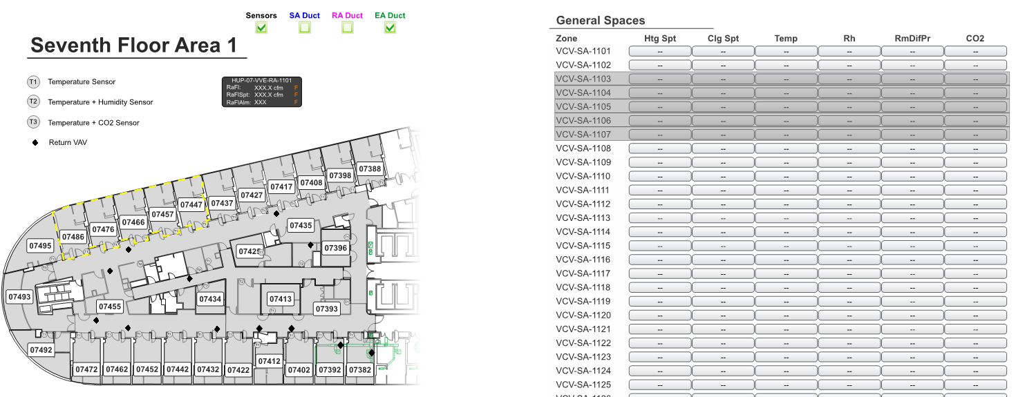

* If Return Air Flow is in Alarm, an alarm bell will display above the black diamond to indicate an alarm associated with that VAV is active.

## 2.2 Floor Level Features

* Floor level graphics will present the user with an entire floor of the building.

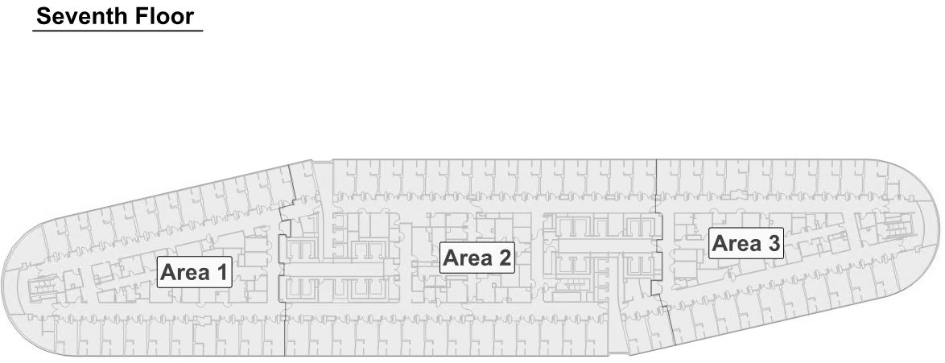

* The user will have the option to access all areas in the floor by hovering over and clicking the desired area. When hovering over an area, the area acts as a zone component. The label enlarges and a dashed yellow outline appears.

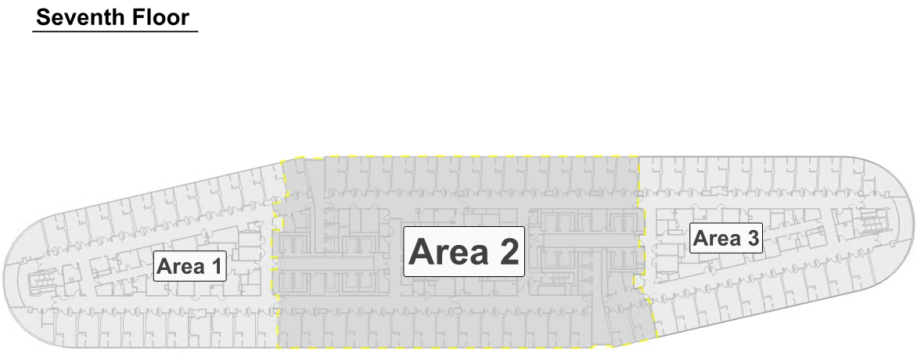

## 2.3 Mechanical Floors

* Floor Components
  + The mechanical levels in the building, L2, L2 Mezzanine, L15, L15M, L16 and Roof contain many pieces of mechanical equipment. This section will explain the visual indications associated with each piece of mechanical equipment
  + Visual Indications
    - Running Fill – a green fill for the component. When the equipment is running, a green fill will appear superimposed on the component

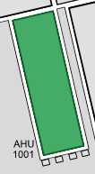

* + - Maintenance Mode – When equipment is in maintenance mode, a purple halo surrounds the component

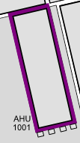

* + - Alarm – When equipment is in alarm, a red halo surrounds the component and an alarm bell is displayed in the center of the equipment.

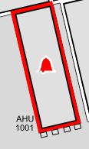

# 3. NAVIGATION SPECIFICATIONS

## 3.1 Navigation Header

* The navigation header is the blue bar at the top of every page. It consists of the following:
  + Penn’s logo



* + The name of the hospital (UPHS – The Pavilion)



* + Home & Back button



* + Outside air temperature, humidity and CO2 with weather indicator

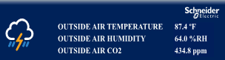

* + Navigation buttons
  + Altogether, the navigation header looks like:

## 3.2 Navigation Header Features

* The home button will navigate to the main splash page.
* The back button will navigate to the last page the user was on.
* Clicking on a navigation button will open a drop-down menu of the appropriate graphics within that category
* For example, clicking on the water systems button will open the following drop down menu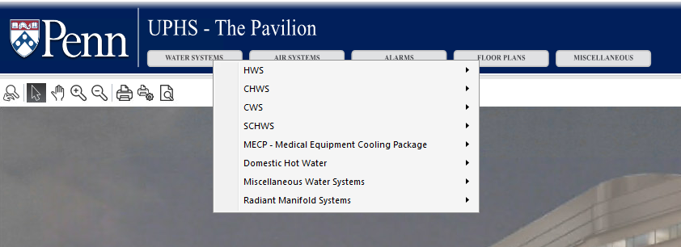

# 4 REVIEW AND ACCEPTANCE

## Approval

### By signing below, I agree to the items listed above, and approve the graphics package development to proceed. I understand that all changes, beyond what is listed above, may come at additional cost.

### Signature: __________________________________________________________________

### Date: ______________________________________________________________________